larvae_fab

Fabrice

2025-03-22

## R Markdown

This is an R Markdown document. Markdown is a simple formatting syntax for authoring HTML, PDF, and MS Word documents. For more details on using R Markdown see <http://rmarkdown.rstudio.com>.

When you click the **Knit** button a document will be generated that includes both content as well as the output of any embedded R code chunks within the document. You can embed an R code chunk like this:

d <- read.csv("/Users/fabriceg/Data_forensic/Larval_weight_Fabrice.csv", header = TRUE, sep = ",")  
  
d$weight_gain <- d$after_3_days - d$before_experiment  
  
names(d)

## [1] "species" "chamber_temp" "rep"   
## [4] "density" "before_experiment" "after_3_days"   
## [7] "weight_gain"

str(d)

## 'data.frame': 3900 obs. of 7 variables:  
## $ species : chr "C.vicina" "C.vicina" "C.vicina" "C.vicina" ...  
## $ chamber_temp : int 30 30 30 30 30 30 30 30 30 30 ...  
## $ rep : int 1 1 1 1 1 1 1 1 1 1 ...  
## $ density : int 50 50 50 50 50 200 200 200 200 200 ...  
## $ before_experiment: num 0.0287 0.0375 0.0379 0.0333 0.0225 0.0316 0.0328 0.0381 0.034 0.0342 ...  
## $ after_3_days : num 0.0758 0.0925 0.0843 0.0901 0.0733 0.086 0.0871 0.0918 0.0881 0.0884 ...  
## $ weight_gain : num 0.0471 0.055 0.0464 0.0568 0.0508 0.0544 0.0543 0.0537 0.0541 0.0542 ...

d$species <- as.factor(d$species)  
d$chamber_temp <- as.factor(d$chamber_temp)  
d$rep <- as.factor(d$rep)  
d$density <- factor(d$density, levels = c("50", "200","1000", "2000"))  
  
CV <- subset(d, species == "C.vicina")  
LS <- subset(d, species == "L.sericata")

d_CV <- lmer(weight_gain ~ chamber_temp + density+ chamber_temp * density + (1|rep), data = CV)  
summary(d_CV)

## Linear mixed model fit by REML. t-tests use Satterthwaite's method [  
## lmerModLmerTest]  
## Formula: weight_gain ~ chamber_temp + density + chamber_temp * density +   
## (1 | rep)  
## Data: CV  
##   
## REML criterion at convergence: -12495.3  
##   
## Scaled residuals:   
## Min 1Q Median 3Q Max   
## -3.7486 -0.6080 -0.0468 0.6308 3.8012   
##   
## Random effects:  
## Groups Name Variance Std.Dev.  
## rep (Intercept) 1.976e-06 0.001406  
## Residual 9.194e-05 0.009589  
## Number of obs: 1950, groups: rep, 3  
##   
## Fixed effects:  
## Estimate Std. Error df t value Pr(>|t|)  
## (Intercept) 4.708e-02 2.605e-03 1.718e+02 18.070 <2e-16  
## chamber_temp30 1.720e-03 3.501e-03 1.940e+03 0.491 0.6233  
## density200 6.632e-03 2.768e-03 1.940e+03 2.396 0.0167  
## density1000 -2.604e-02 2.537e-03 1.940e+03 -10.263 <2e-16  
## density2000 -3.339e-02 2.507e-03 1.940e+03 -13.321 <2e-16  
## chamber_temp30:density200 -5.365e-03 3.915e-03 1.940e+03 -1.371 0.1707  
## chamber_temp30:density1000 -4.049e-03 3.588e-03 1.940e+03 -1.129 0.2592  
## chamber_temp30:density2000 3.292e-03 3.545e-03 1.940e+03 0.929 0.3531  
##   
## (Intercept) ***  
## chamber_temp30   
## density200 *   
## density1000 ***  
## density2000 ***  
## chamber_temp30:density200   
## chamber_temp30:density1000   
## chamber_temp30:density2000   
## ---  
## Signif. codes: 0 '***' 0.001 '**' 0.01 '*' 0.05 '.' 0.1 ' ' 1  
##   
## Correlation of Fixed Effects:  
## (Intr) chm_30 dns200 dn1000 dn2000 ch_30:200 c_30:1  
## chmbr_tmp30 -0.672   
## density200 -0.850 0.632   
## density1000 -0.927 0.690 0.873   
## density2000 -0.939 0.698 0.883 0.964   
## chmb_30:200 0.601 -0.894 -0.707 -0.617 -0.625   
## chm_30:1000 0.656 -0.976 -0.617 -0.707 -0.682 0.873   
## chm_30:2000 0.664 -0.988 -0.625 -0.682 -0.707 0.883 0.964

anova(d_CV, type = 3)

## Type III Analysis of Variance Table with Satterthwaite's method  
## Sum Sq Mean Sq NumDF DenDF F value Pr(>F)   
## chamber_temp 0.000003 0.000003 1 1940 0.0354 0.8509   
## density 0.162814 0.054271 3 1940 590.2817 < 2.2e-16 ***  
## chamber_temp:density 0.006476 0.002159 3 1940 23.4784 6.318e-15 ***  
## ---  
## Signif. codes: 0 '***' 0.001 '**' 0.01 '*' 0.05 '.' 0.1 ' ' 1

d_LS <- lmer(weight_gain ~ chamber_temp * density + (1|rep), data = LS)  
summary(d_LS)

## Linear mixed model fit by REML. t-tests use Satterthwaite's method [  
## lmerModLmerTest]  
## Formula: weight_gain ~ chamber_temp * density + (1 | rep)  
## Data: LS  
##   
## REML criterion at convergence: -16035.8  
##   
## Scaled residuals:   
## Min 1Q Median 3Q Max   
## -4.1913 -0.6867 -0.0116 0.6523 3.3820   
##   
## Random effects:  
## Groups Name Variance Std.Dev.   
## rep (Intercept) 9.927e-07 0.0009964  
## Residual 1.483e-05 0.0038515  
## Number of obs: 1950, groups: rep, 3  
##   
## Fixed effects:  
## Estimate Std. Error df t value Pr(>|t|)  
## (Intercept) 1.439e-02 1.149e-03 3.014e+01 12.523 1.78e-13  
## chamber_temp30 3.440e-03 1.406e-03 1.940e+03 2.446 0.014532  
## density200 2.825e-03 1.112e-03 1.940e+03 2.541 0.011135  
## density1000 -1.030e-02 1.019e-03 1.940e+03 -10.112 < 2e-16  
## density2000 -7.471e-03 1.007e-03 1.940e+03 -7.421 1.74e-13  
## chamber_temp30:density200 -3.272e-03 1.572e-03 1.940e+03 -2.081 0.037589  
## chamber_temp30:density1000 -1.673e-03 1.441e-03 1.940e+03 -1.161 0.245720  
## chamber_temp30:density2000 -5.177e-03 1.424e-03 1.940e+03 -3.636 0.000284  
##   
## (Intercept) ***  
## chamber_temp30 *   
## density200 *   
## density1000 ***  
## density2000 ***  
## chamber_temp30:density200 *   
## chamber_temp30:density1000   
## chamber_temp30:density2000 ***  
## ---  
## Signif. codes: 0 '***' 0.001 '**' 0.01 '*' 0.05 '.' 0.1 ' ' 1  
##   
## Correlation of Fixed Effects:  
## (Intr) chm_30 dns200 dn1000 dn2000 ch_30:200 c_30:1  
## chmbr_tmp30 -0.612   
## density200 -0.774 0.632   
## density1000 -0.845 0.690 0.873   
## density2000 -0.855 0.698 0.883 0.964   
## chmb_30:200 0.547 -0.894 -0.707 -0.617 -0.625   
## chm_30:1000 0.597 -0.976 -0.617 -0.707 -0.682 0.873   
## chm_30:2000 0.605 -0.988 -0.625 -0.682 -0.707 0.883 0.964

anova(d_LS, type = 3)

## Type III Analysis of Variance Table with Satterthwaite's method  
## Sum Sq Mean Sq NumDF DenDF F value Pr(>F)   
## chamber_temp 0.0000749 0.0000749 1 1940 5.0512 0.02472 *   
## density 0.0184057 0.0061352 3 1940 413.5966 < 2e-16 ***  
## chamber_temp:density 0.0013586 0.0004529 3 1940 30.5290 < 2e-16 ***  
## ---  
## Signif. codes: 0 '***' 0.001 '**' 0.01 '*' 0.05 '.' 0.1 ' ' 1

## Including Plots

You can also embed plots, for example:

ggplot(LS, aes(x = density, y = weight_gain, fill = density)) +  
 stat_summary(fun = mean, geom = "bar", color = "black") +  
 stat_summary(fun.data = mean_se, geom = "errorbar", width = 0.2) +  
 theme_classic()

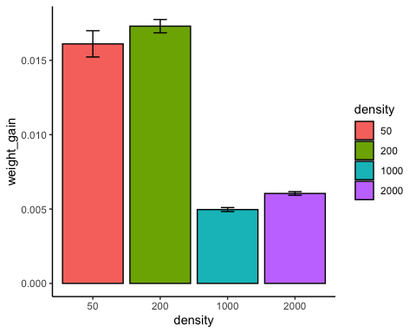

ggplot(LS, aes(x = chamber_temp, y = weight_gain, fill = chamber_temp)) +  
 stat_summary(fun = mean, geom = "bar", color = "black") +  
 stat_summary(fun.data = mean_se, geom = "errorbar", width = 0.2) +  
 theme_classic()

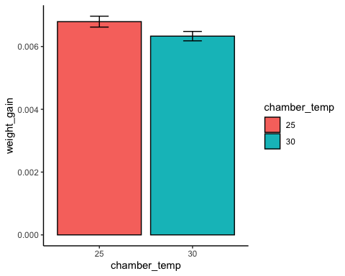

ggplot(CV, aes(x = density, y = weight_gain, fill = chamber_temp)) +  
 geom_boxplot() +  
 scale_fill_manual(values = c("blue", "red"))

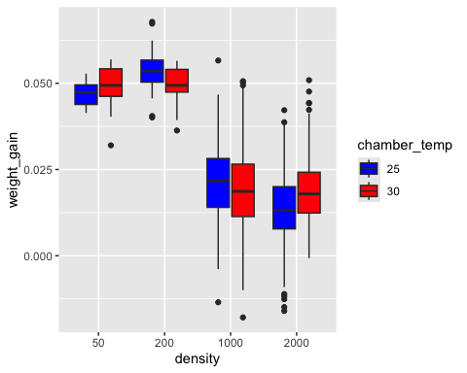

labs(title = "Larval weight gain across density levels and temperatures",  
 x = "Density",  
 y = "Weight gain (g)",  
 fill = "Chamber temperature") +  
 theme_minimal()

## NULL

ggplot(CV, aes(x = density, y = weight_gain, fill = chamber_temp)) +  
 geom_boxplot(outlier.shape = 21, outlier.fill = "white", outlier.color = "black") +  
 scale_fill_manual(values = c("gray30", "gray70")) +  
 labs(title = "Larval weight gain across density levels and temperatures",  
 x = "Density",  
 y = "Weight gain (g)",  
 fill = "Chamber temperature") +  
 theme_minimal() +  
 theme(panel.grid.major = element_blank(),   
 panel.grid.minor = element_blank(),  
 legend.position = "top",  
 text = element_text(size = 14))

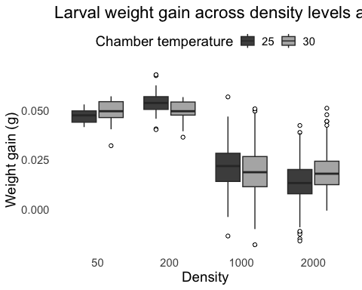

ggplot(LS, aes(x = density, y = weight_gain, fill = chamber_temp)) +  
 geom_boxplot(outlier.shape = 21, outlier.fill = "white", outlier.color = "black") +  
 scale_fill_manual(values = c("gray30", "gray70")) +   
 labs(title = "Larval weight gain across density levels and temperatures",  
 x = "Density",  
 y = "Weight gain (g)",  
 fill = "Chamber temperature") +  
 theme_minimal() +  
 theme(panel.grid.major = element_blank(),   
 panel.grid.minor = element_blank(),  
 legend.position = "top",  
 text = element_text(size = 14))

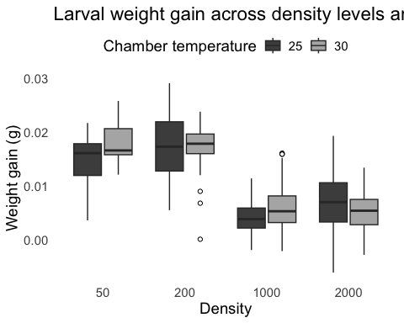

ggplot(CV, aes(x = density, y = weight_gain, fill = density)) +  
 stat_summary(fun = mean, geom = "bar", color = "black") +  
 stat_summary(fun.data = mean_se, geom = "errorbar", width = 0.2) +  
 theme_classic()

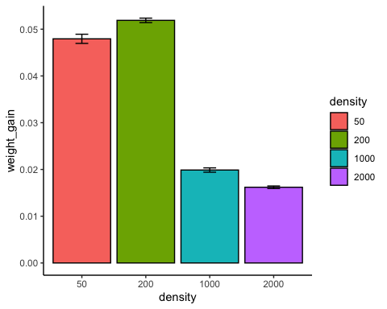

ggplot(CV, aes(x = chamber_temp, y = weight_gain, fill = chamber_temp)) +  
 stat_summary(fun = mean, geom = "bar", color = "black") +  
 stat_summary(fun.data = mean_se, geom = "errorbar", width = 0.2) +  
 theme_classic()

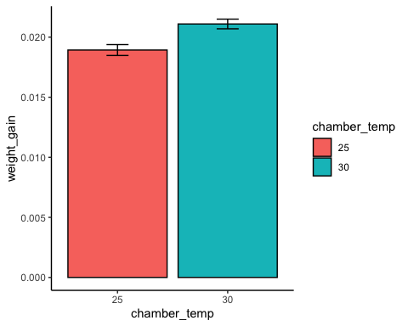

Note that the echo = FALSE parameter was added to the code chunk to prevent printing of the R code that generated the plot.